12/1/2022

WGB340 Final Project Storyboard
Microsite for Komfort Kicks

In this project I would like to use a lot of blue and white color combinations. Some of the background images I’m considering are:








These background images were found at pixabay.com

For my home site, I would like to feature this image I found of Ricardo Izecson Dos Santos (KAKA):



I’d like to utilize this image and use an alpha color effect to fade it in and out on the home page.

I would like to make the copy below a feature on the home page:
Kaka is a Brazilian soccer player with goal scoring ability, technical skills and elegance. Kaka made his professional debut at young age of 18 at Sao Paulo, Brazil. His charismatic presence on and off the field inspires other young players to make a difference and play with Komfort!

On the home page we need to include this logo – it says near the bottom:

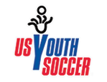
The blue, white and red will go along nicely with my design.

I will add this copy as indicated on the site page near the youth soccer logo:

Komfort Kicks is a proud sponsor of US Youth Soccer, a non-profit and educational organization whose mission is to foster development of America's youth through the sport of soccer at all levels of age and competition.
I’ve got an idea to utilize the lesson 10 over info buttons to create readable good-looking copy for both of these word heavy additions:

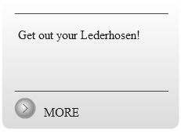

I’ve been playing with the symbol a little bit and came up with this:
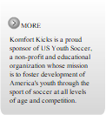

I’d like to use this style throughout which also keeps with my color themes.

When users click, they can be directed to the websites we are utilizing: https://www.usyouthsoccer.org

Here is what the earlier copy will look like as a button:

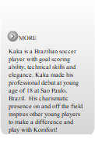

This will be a link to my main site that I am creating.

For the athletic wear, I’d like to utilize the following images:

ActiveWear Content page will include some of the same styles used on the main page to keep with the theme and will include images such as below:
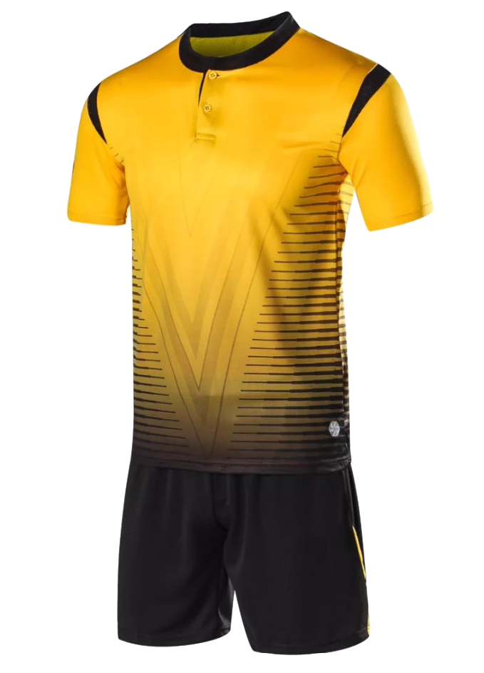
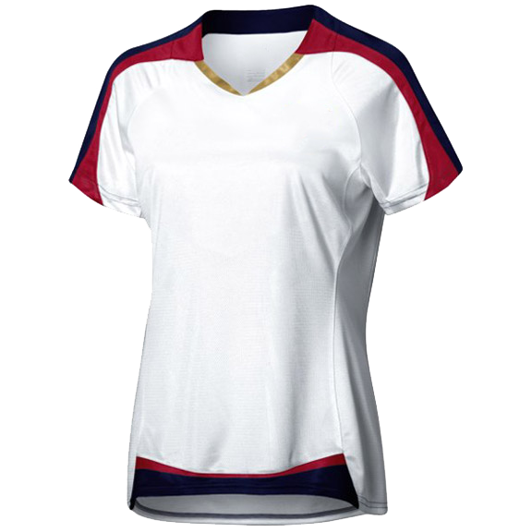

The NeonKick Content Page will include images such as below:

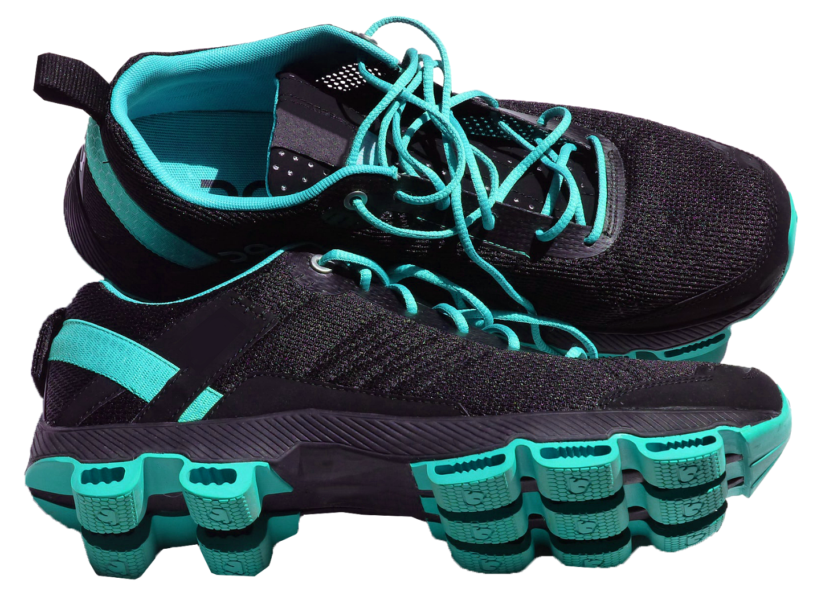

The KomfortKicks Logo will be prominently displayed throughout my microsite:



Some other images I am thinking of including are:







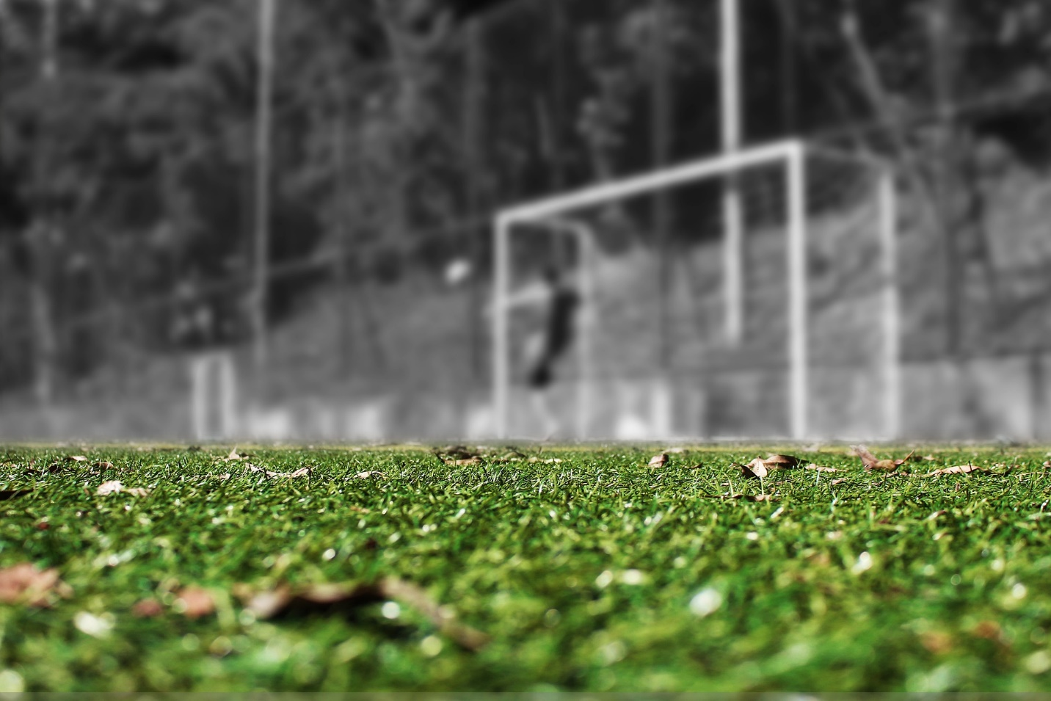

https://en.wikipedia.org/wiki/Kak%C3%A1

