11/6/2022
Week 3 – Adobe Animate

Storyboard for Haiku

In week three we are creating an animated Haiku. Below is a storyboard of how I will create my Haiku.

My Haiku Poem:
Ode to the flower (5 syllables)
Beautiful flower so tall (7 syllables)
Flower in my HEART (5 syllables)

Background Image:
Photo credit – taken by myself, Katie DeWerdt
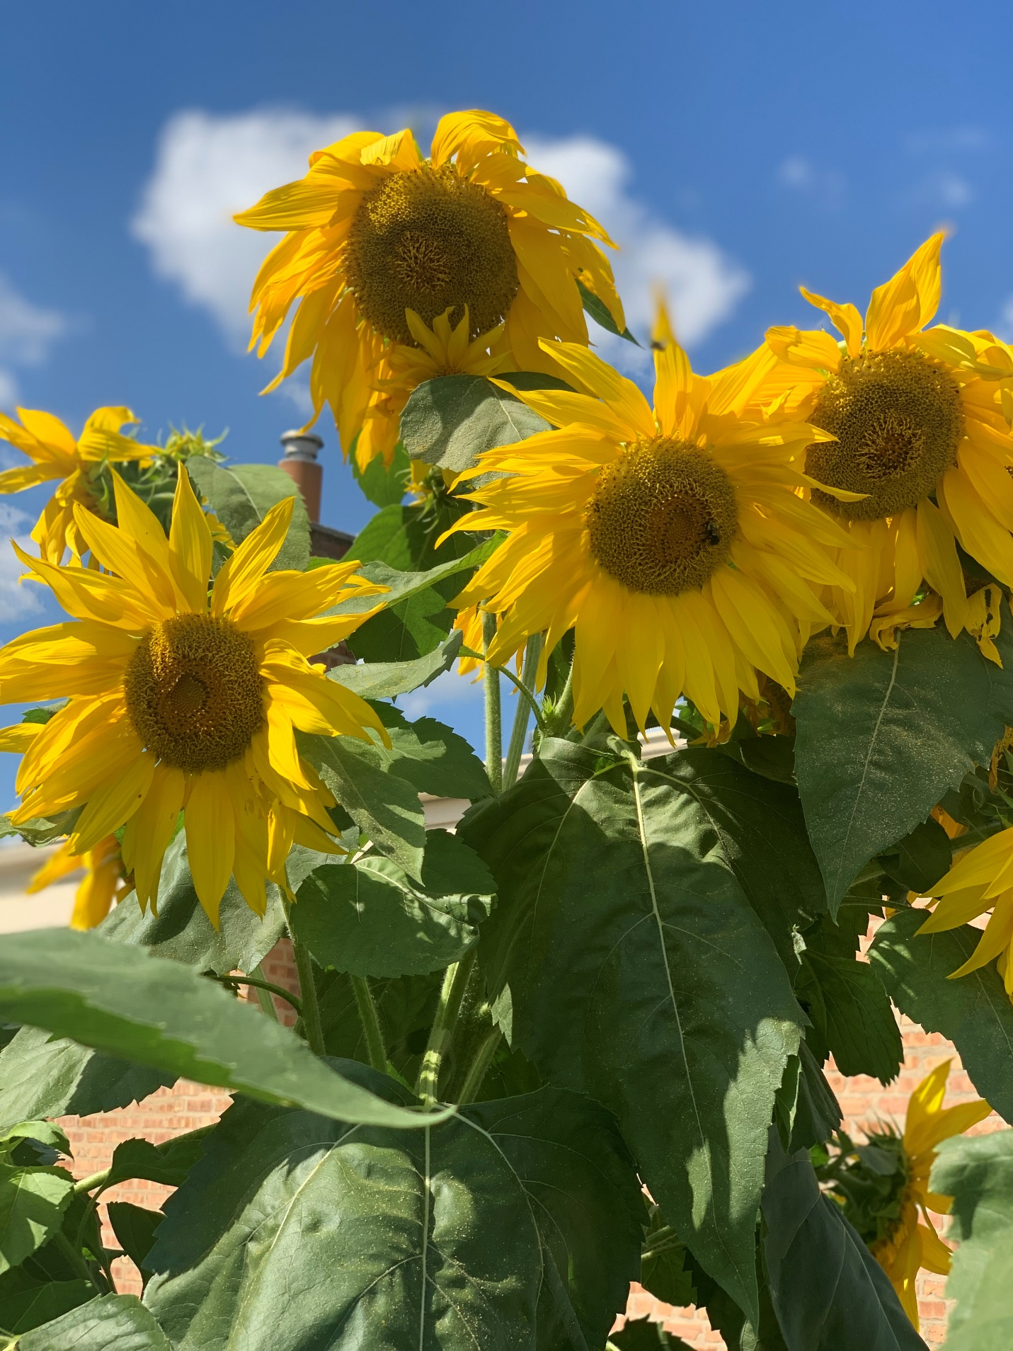

Image that will be used for several frames and duplicated:
Photo credit: Pixabay.com

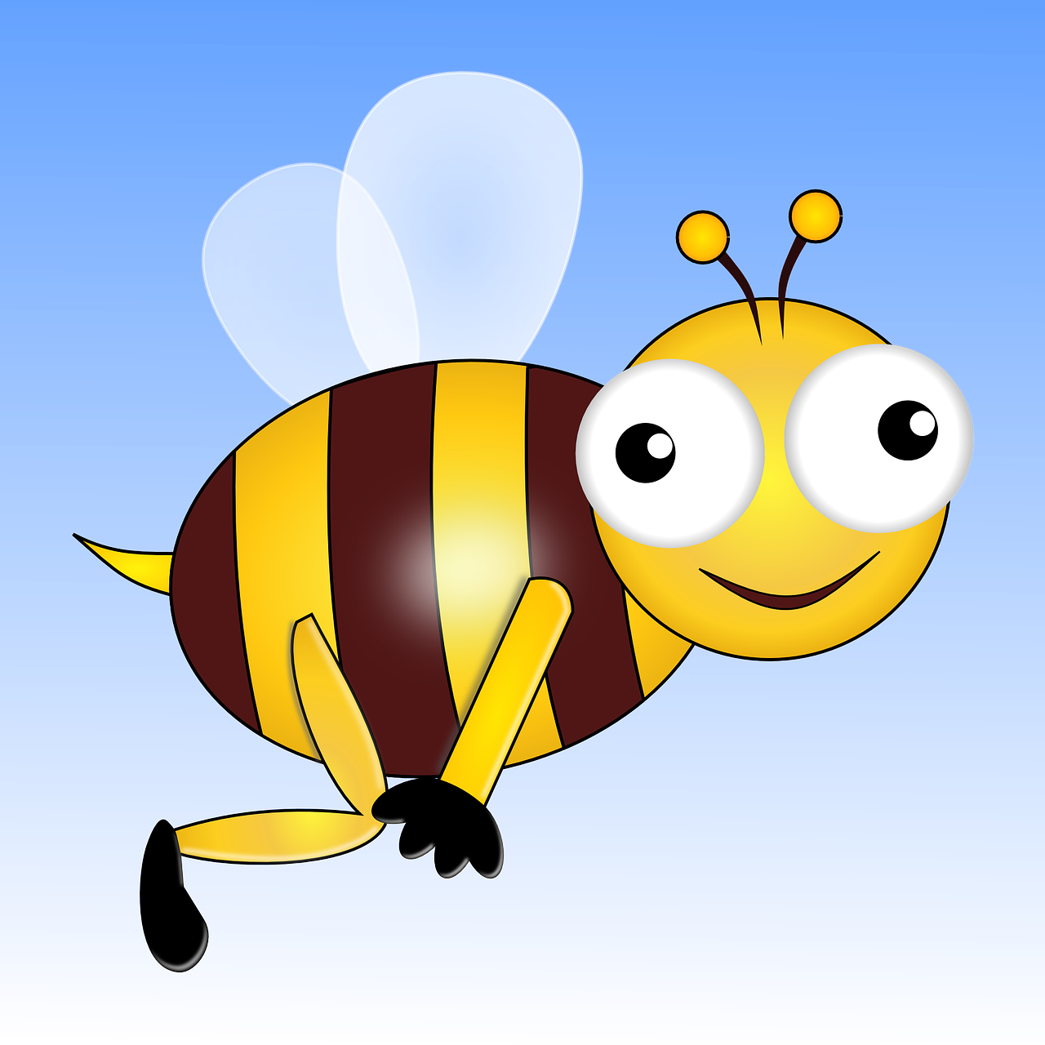

Color Choices: the color choices for this project will be a lot of yellow, green, blue and brown to match the images shown. I may use white for the text to standout.

Text Font Choice:
I will use Lucida Bright with Bold selected. While completing the assignment, I will experiment to see what color text will look best. This is 28pt Lucida Bright bold.

Plan:
I will move the bee along in different frames and add the text in different frames for the animation effect.

